Grade: 7

Subject: Math

Big Idea:
The constant ratio between the circumference and diameter of circles can be used to describe, measure, and compare spatial relationships.

Key Concepts:
• Relationships

Content:
• Circumference and area of circles

Essential Questions:
• How do we measure circles?
• How can one part of a circle help us determine the measurement of another part?

Curricular Competencies:

Reasoning and Analyzing
• estimate reasonably using ‘friendly’ numbers (eg. multiply diameter by 3 to find the approx. circumference)
• use tools (protractor, compass, centimeter grids and tiles) to explore relationships

Understanding and Solving
• develop, demonstrate, and apply an understanding of shape and space through play, inquiry, and problem solving

Communicating and Representing
• accurately use mathematical vocabulary (circumference, radius, diameter, chord, area, pi) in mathematical discussions
• communicate mathematical thinking about shape, space, and measurement in many ways

Connecting and Reflecting
• incorporate First Peoples worldviews (medicine wheel, drum skin)

Summative Performance Assessment:

Have students design a waterpark with circular water features (hot tubs, pools, playgrounds).

To add complexity, pools can have decorative islands inside. Islands would have to subtracted from the total area in order to determine the surface area covered in water.

Teacher can require certain features to have an exact, minimum or maximum measurement. (e.g. the hot tub must have a circumference of 10.5m)

Ideas to Promote Inquiry through e-Learning:
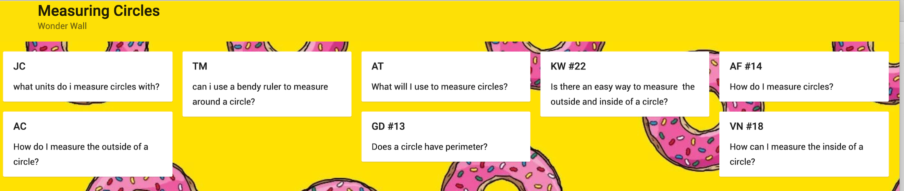

• Have students ask their own questions related to measuring circles. Record their questions and have them refer back as the unit progresses.
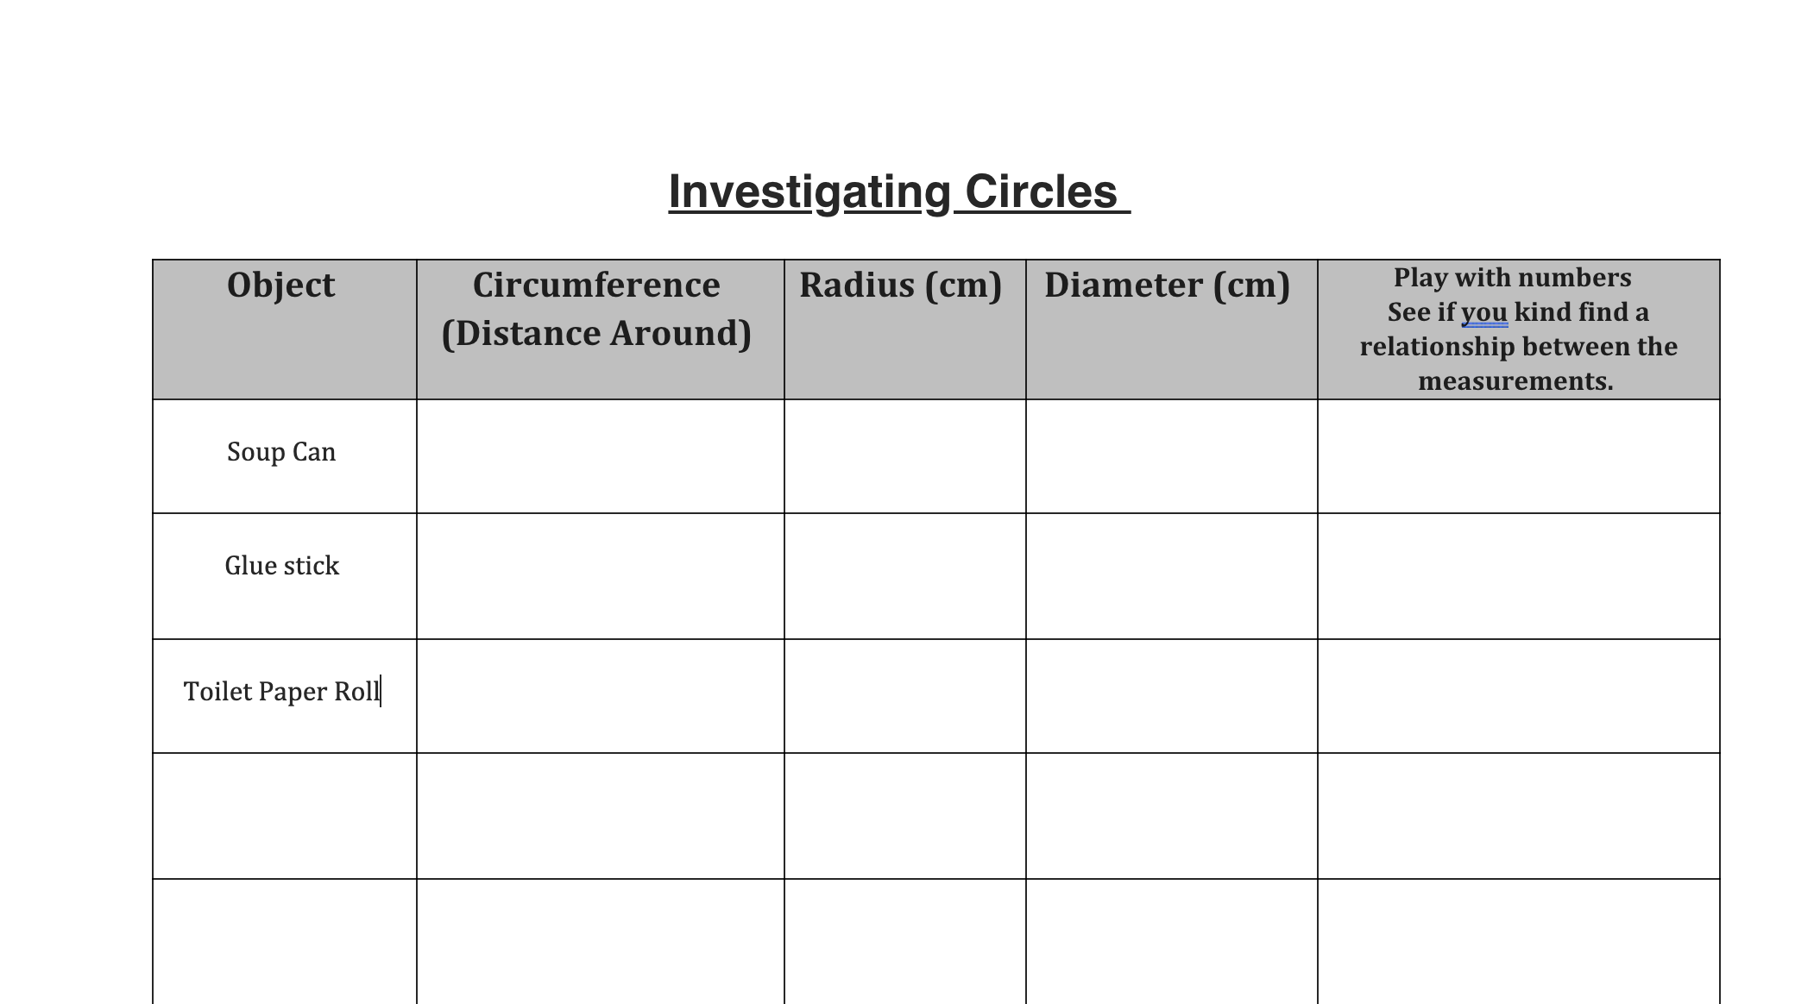

• Have students measure household items. Get them to experiment with different equations to try and find a spatial relationship between different parts of the circle

Questions to Consider:
- What are the essential questions students need to answer?
- How are the essential questions connected to the performance/summative task?
- How can the summative task reflect authentic work connected to the areas of study/discipline?
- What problem will the students solve?
- Will the inquiry allow students to self-direct and have agency in their learning?
- How can you augment or redefine the use of technology
to enhance student learning?
- What will the students be able to transfer to their next inquiry?
Online Instructional Model
The TRUDACOT Protocol (4 Shifts Protocol) assists educators with the (re)design of lessons, units, and instructional activities and to think about
      - deeper learning
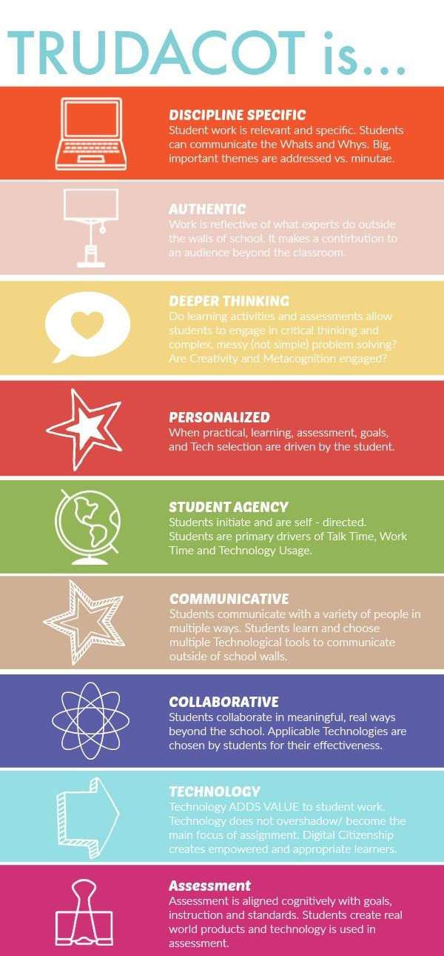
- greater student agency
- more authentic work
- rich technology infusion.

Teaching Online:
BeginningLevel 1: Continue using mail messaging, class blogs, Power Point, e-books, you tube videos, Google images, etc. Begin to explore Microsoft Teams.
DevelopingLevel 2: Explore the functions of the Microsoft Teams platform (video, chat, meeting rooms, file sharing, etc.).
Practicing Level 3: Integrate additional digital technology tools (e.g. Padlet, Animoto, MindMup 2.0, Book Creator, Explain Everything, ShowMe, HaikuDeck, Camtasia, etc.) and explore educational streaming tools (e.g. Curio.ca).

