Conceptual Planning Framework
Big Idea: Genes are the foundation for the diversity of living things
Key Concepts: Patterns, Biodiversity
Content: Patterns of Inheritance, Mechanisms for the diversity of life
Essential Questions: How do patterns determine outcomes? Why does biodiversity matter?

Curricular Competencies:
Processing and analyzing data and information
– Construct, analyze, and interpret models
– Seek and analyze pattern, trends and connections in data, including describing relationships between variables.
– Use knowledge of scientific concepts to draw conclusions that are consistent with evidence
– Apply First Peoples perspectives and knowledge, other ways of knowing, and local knowledge as sources of information

Evaluating
– Evaluate the limitations of a model in relation to the phenomenon modelled
– Critically analyze the validity of information in secondary sources

Communicating
– Express and reflect on a variety of perspectives, and worldviews through place

First People’s Principles of Learning:
– Learning recognizes the role of Indigenous knowledge
– Learning is embedded in memory, history and story

Ideas to promote Inquiry through E-learning:
Create visual hooks and incorporate visible thinking routines using Padlet or Powerpoint
Zooming in See, Think, Wonder Think, Puzzle, Explore Observe, Infer, Explain

Summative Performance Assessment:
The Story behind the Spirit Bear
Core Competency Facets
- Communication: Focussing on Intent and Purpose, Acquiring and Presenting Information
- Thinking: Designing and Developing (Critical), Creating and Innovating (Creative)

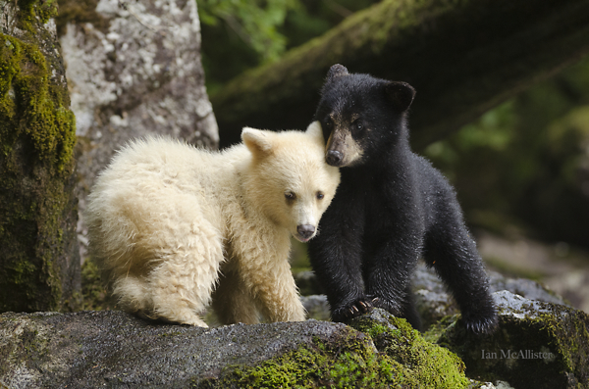
The goal of this project is to learn about the legend and the genetics of the Spirit Bear by researching it and then creating an electronic storybook based on the information. The storybooks you create may then be shared with our Elementary Family of Schools.

To begin your research, please explore the website link below. Ms. Black and her fellow teacher librarians have been working hard to create web-based resources pages for all subject areas.
https://libguides.sd44.ca/c.php?g=715805&p=5104657

Please also be reminded that you also have access to vetted research sources and educational search engines within the BC Digital Classroom (Username: sd44user, Password: nvsd44). https://libguides.sd44.ca/onlinetools/researchdb

Research Focus:
- The common name and the scientific name (Genus species) of the Spirit Bear
- A description of the genetics of the Spirit Bear (Mendelian or Non-mendelian Inheritance? Dominant or Recessive? Genotypes and Phenotypes? Frequency? etc.)
- A description of their ecosystem (location/range, diversity, importance of their habitat etc.)
- The First Peoples’ name for the Spirit Bear
- A description of the Kitasoo Xai'xais Legend of the Spirit Bear https://www.youtube.com/watch?time_continue=4&v=A5HORdG_8mA
- A summary of the evolutionary advantages afforded by white fur colour
- A record of your sources (APA Bibliography)
The electronic storybook you create should contain “chapters” for all of your research findings as well as an original children’s story, authored by you, which incorporates key aspects of your research into the story line. Illustrations/images which support the text should also be included.
- There are many ways you may choose to publish your project. Those who enjoy art may choose to hand draw and illustrate their story book. They may choose to film themselves reading their book and upload a video file for evaluation.
- Alternately, platforms such as Piktochart (https://piktochart.com/) can be used to create an electronic storybook. Although not the only platform to do so, this program is free, accessible and creates professional looking products.
- The final page of your book should be the reference page formatted in the style of an APA bibliography. Please refer to the following website for support: http://libguides.sd44.ca/argylesecondary/apa
~ Project Idea adapted from WCLN.ca

Questions to Consider:
- What are the essential questions students need to answer?
- How are the essential questions connected to the performance/summative task?
- How can the summative task reflect authentic work connected to the areas of study/discipline?
- What problem will the students solve?
- Will the inquiry allow students to self-direct and have agency in their learning?
- How can you augment or redefine the use of technology to enhance student learning ?
- What will the students be able to transfer to their next inquiry?

Online Instructional Model
The TRUDACOT Protocol (4 Shifts Protocol) assists educators with the (re)design of lessons, units, and instructional activities and to think about
      - deeper learning
- greater student agency
- more authentic work
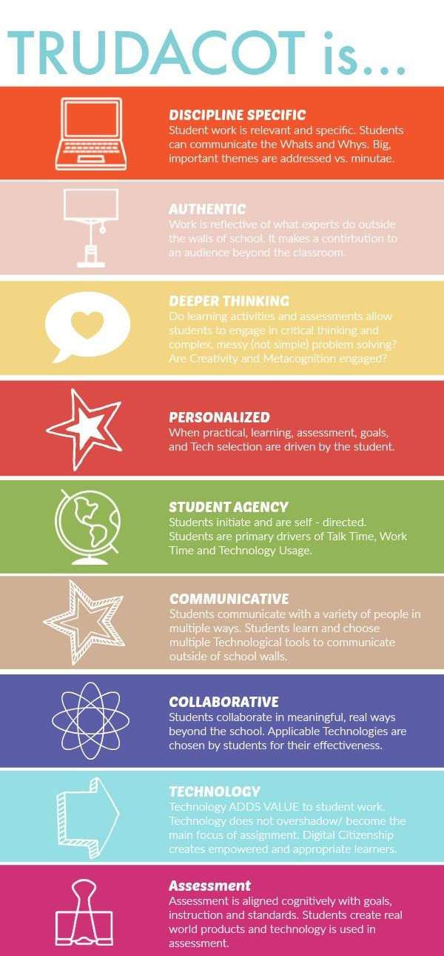
- rich technology infusion.

Teaching Online:
BeginningLevel 1:
Continue using mail messaging, class blogs, Power Point, e-books, you tube videos, Google images, etc. Begin to explore Microsoft Teams.

DevelopingLevel 2:
Explore the functions of the Microsoft Teams platform (video, chat, meeting rooms, file sharing, etc.).

Practicing Level 3:
Integrate additional digital technology tools (e.g. Padlet, Animoto, MindMup 2.0, Book Creator, Explain Everything, ShowMe, HaikuDeck, Camtasia, etc.) and explore educational streaming tools (e.g. Curio.ca).

