Pre-Visit Lesson Plan

GRADE(S): 4

DURATION: 45 mins to 1 hour
CONTEXT/RATIONALE: An introduction to Outdoor School through the lens of senses. This lesson will support students to prepare for their first trip to Outdoor School.

Lesson Focus, Big Idea and/or Critical Question(s)
Introduction to Senses and SEL at Outdoor School:
- What are senses? What do you wonder about your senses? What might you notice with your senses at outdoor school? What do you know or wonder about the senses of other living things (like salmon, birds, trees, goats, chickens, pigs, pond species)?
- How can we prepare ourselves for our visit to Outdoor School? What is expected of us when we are there?

Curriculum Connections (Big Ideas, Content, Curricular Competencies)
All living things sense and respond to their environment.

Specific Lesson Objectives (SLO’s) – I can …
… I can state what senses are and identify three things I might sense at Outdoor School.
… I can plan to be successful at Outdoor School.
… I can communicate what is expected of me at Outdoor School.

Materials and Resources – what does the teacher need and what do the learners need
Sensory Wake-up Circle, Get Outdoors Manual, p. 42-43
Slideshow, Access to video potentially (see below for links)
Printed Copy of Compass Activity & Learning Journal
Paper to collect suggestions for cabinmates.
Printed copy of Outdoor Learning Core Competencies Self-Assessment

Note: all supporting documents can be found on the Environmental Learning Resources Tab

INTRODUCTION: How will the lesson begin and engage learners? How will you connect to and activate learners’ prior knowledge?

Hook:
- Do the Sensory Wake-up Circle Activity from the Get Outdoors Manual p.42-43

- Show Place-based video from the Outdoor School to share some of the sights they may see when they participate in Outdoor School: Nature is in Session video
Optional: You can also show these videos of Outdoor School as additional visuals (older videos, can be played without volume while you explain elements that are being shown like the dining hall, cabins, field studies and recreation activities, etc.)
- https://www.youtube.com/watch?v=RGMpCQVCWfQ
- https://www.youtube.com/watch?v=PkMzKsrZDH4

DEVELOPMENT: What will you do and what will the learners do? Remember to incorporate key questions throughout the lesson development.

Compass Activity: 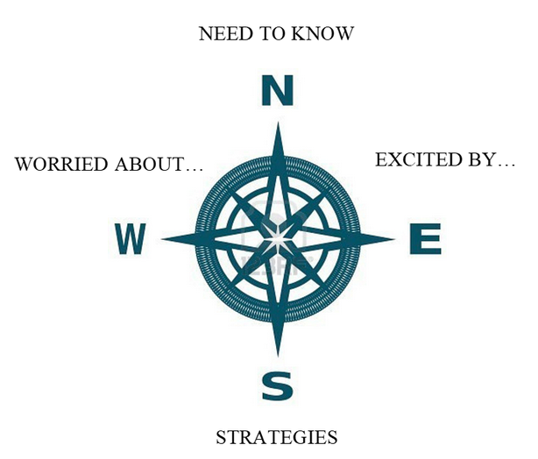
Introduce the concept of the Compass to students. Use the Compass page to gage where the students are at. Go through each of the categories, “Excited”, “Worried”, “Strategies”, “Need to know”. Through debriefing these categories, you should cover these topics:
- What to Pack, Weather expectations
- Counsellor Role & Respect
- Living and Working with others (tie in Core Competency assessment to prepare them)
- Cabin requests, taking suggestions so that each student has a support person in cabins and field studies.
CLOSURE: How will the lesson end in a meaningful way?

End with a general Q & A Period, try to avoid “what if” questions. End with Core Competency assessment to help clarify student expectations.
This could be a great time to introduce the Grade 4 Outdoor School Learning Journal: You can assign a page or two to start and students can work on some of it during their time at Outdoor School as well.

ASSESSMENT: How will you know that the learners met/learned/understood the SLO’s?
Refer to the Outdoor Learning Core Competencies Self-Assessment document on the Curriculum Hub

Assessment FOR Learning (What will happen throughout the lesson to check understanding?)

Assessment AS and OF Learning (How will learners show their understanding of concepts/lesson learning?)

Analysis/Reflection of Lesson: What worked well? What didn’t? Did the learners ‘get it’? Why or why not?

