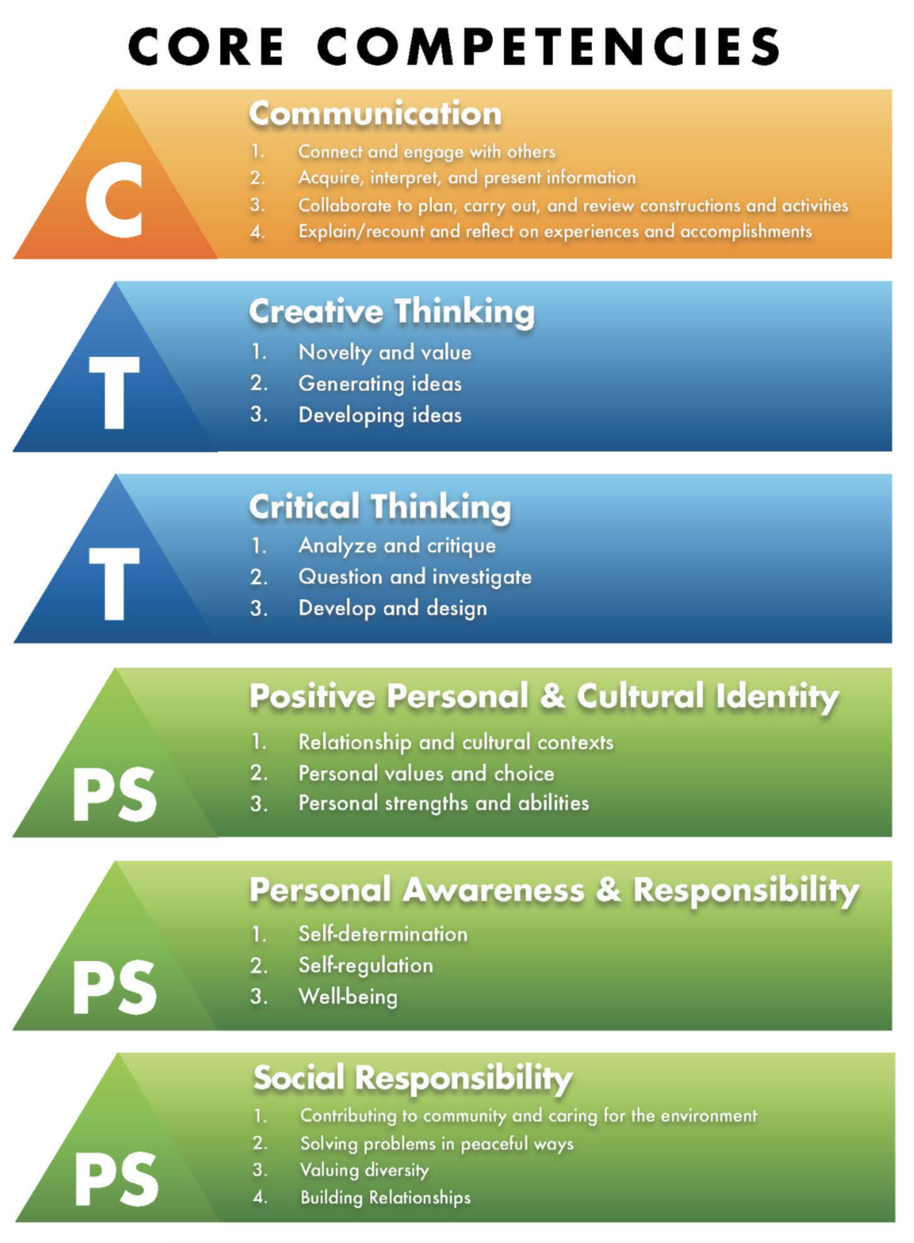
Core Competencies
Understanding the Core Competencies

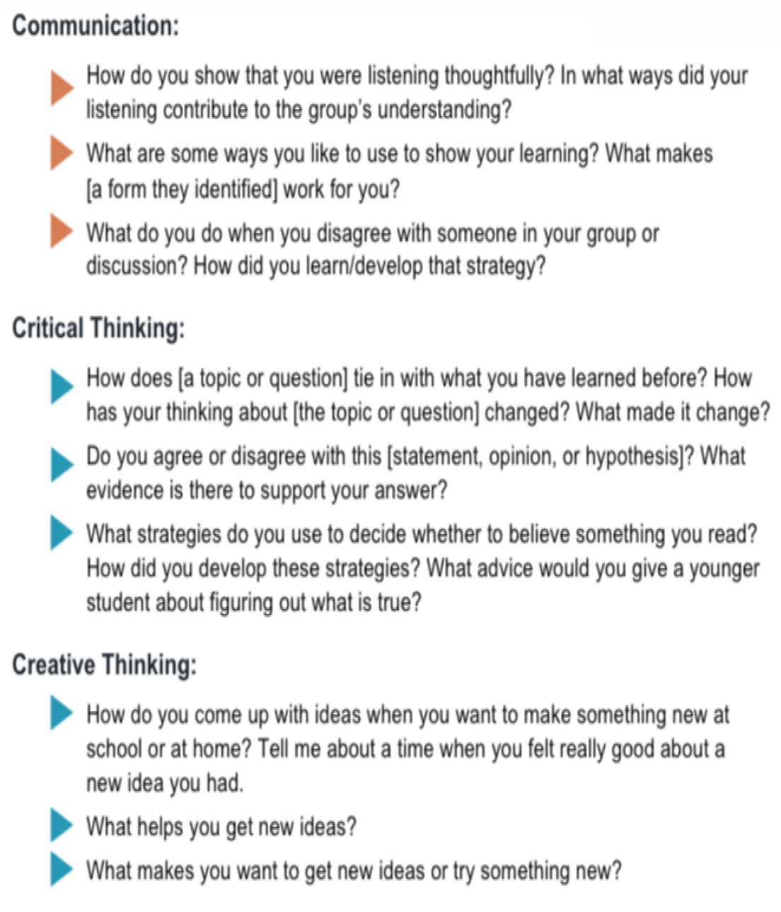
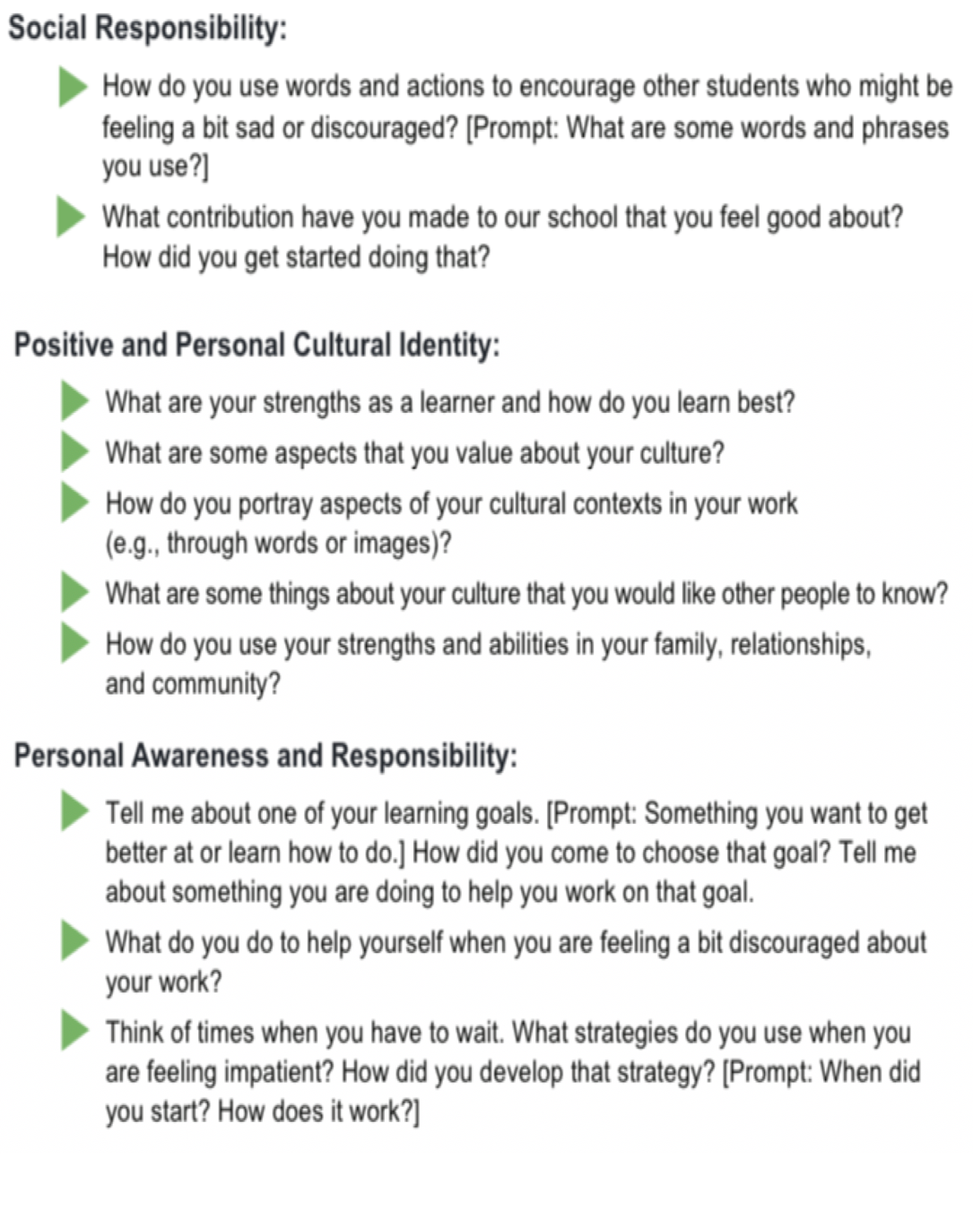
Guiding Questions for Self-Assessment of Core Competencies

Opportunities for self-assessment allow me to develop my ability to describe myself as a unique individual in relation to the core competencies. I set goals and gain greater ownership of my learning when I have the opportunity to self-assess and describe who I am as a learner. It allows me to document my progress and share my accomplishments in an ongoing and holistic manner.

Self-Assessment of Core Competencies

Name | Click or tap here to enter text. | Grade | Choose an item. | Date | Click or tap to enter a date.

Communication | Thinking | Personal & Social
What I do well…  Click or tap here to enter text. | What I do well…  Click or tap here to enter text. | What I do well…  Click or tap here to enter text.
What I need to work on…  Click or tap here to enter text. | What I need to work on…  Click or tap here to enter text. | What I need to work on…  Click or tap here to enter text.
How will I make this happen?  Click or tap here to enter text. | How will I make this happen?  Click or tap here to enter text. | How will I make this happen?  Click or tap here to enter text.
What evidence, examples, and/or schoolwork demonstrates the above…  Click or tap here to enter text. | What evidence, examples, and/or schoolwork demonstrates the above…  Click or tap here to enter text. | What evidence, examples, and/or schoolwork demonstrates the above…  Click or tap here to enter text.

