Thinking Competencies Self-Assessment
 | Name: _____________________________ | Date: ___________________________________
 | Teacher: ___________________________ | Grade: __________________________________

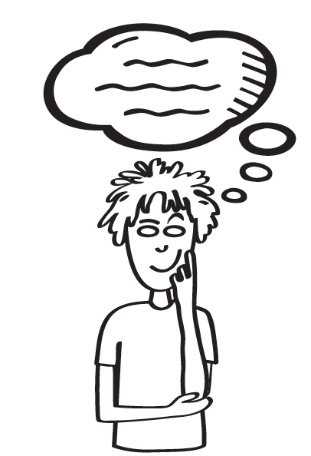

I am proud of:

Here is a drawing to show my thinking skills:

Thinking Competencies Self-Assessment
Name: _____________________________ | Date: ___________________________________
Teacher: ___________________________ | Grade: _________________________________

My goal is to:

To accomplish my goal, I will:

