 | Communication Competencies Self-Assessment
Name: _____________________________ |  | Date: _________________________________
Teacher: ___________________________ |  | Grade: ________________________________
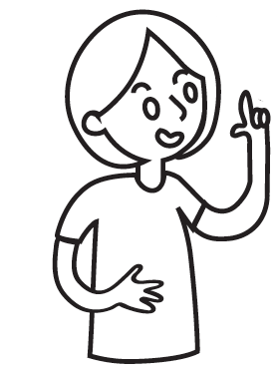

I am proud of:

Here is a drawing to show my communication skills:
Communication Competencies Self-Assessment
Name: _____________________________ | Date: _________________________________
Teacher: ___________________________ | Grade: ________________________________

My goal is to:

To accomplish my goal, I will:

