Core Competencies Self-Assessment
Name ______________________________________________________________ Date: ______________________________________________
Teacher ____________________________________________________________ Grade ____________________________________________

Communication

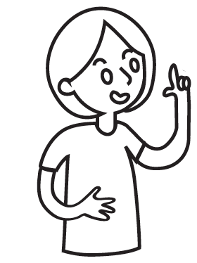
I chose _______________________________ to show how I am developing my communication skills.

It shows my communication because…
_______________________________________________________________________________________________________
_______________________________________________________________________________________________________
_______________________________________________________________________________________________________

I want you to notice…
______________________________________________________________________________________________________
______________________________________________________________________________________________________
______________________________________________________________________________________________________

One thing I would do differently next time is _______________________ because…
___________________________________________________________________________________________________________________________________________
___________________________________________________________________________________________________________________________________________
___________________________________________________________________________________________________________________________________________

To accomplish this, I will…
___________________________________________________________________________________________________________________________________________
___________________________________________________________________________________________________________________________________________
___________________________________________________________________________________________________________________________________________

