Grade: 6

Subject: Social Studies/Language Arts

Big Idea:
• Media sources can both positively and negatively affect our understanding of important events and issues.
• Questioning what we hear, read, and view contributes to our ability to be educated and engaged citizens.

Key Concepts:
• perspective

Content:
• presentation techniques
• take stakeholders’ perspectives on issues, developments, or events by making inferences about their beliefs, values, and motivations

Essential Questions:
• Are photographs real?
• How does advertising effect our choices?
• Can media be unbiased?

Curricular Competencies:
• Respond to text in personal, creative, and critical ways
• Think critically, creatively, and reflectively to explore ideas within, between, and beyond texts
• Media technologies and coverage of current events

Summative Performance Assessments:

Students deconstruct an advertisement or news story.

• students can show “unreal” elements that have been photoshopped or staged

• students can reflect on the bias in the text and/or how the advertisement impacted their willingness or desire to buy a product

• students can identify bias/sensationalism in the ad

Ideas to Promote Inquiry through e-Learning:

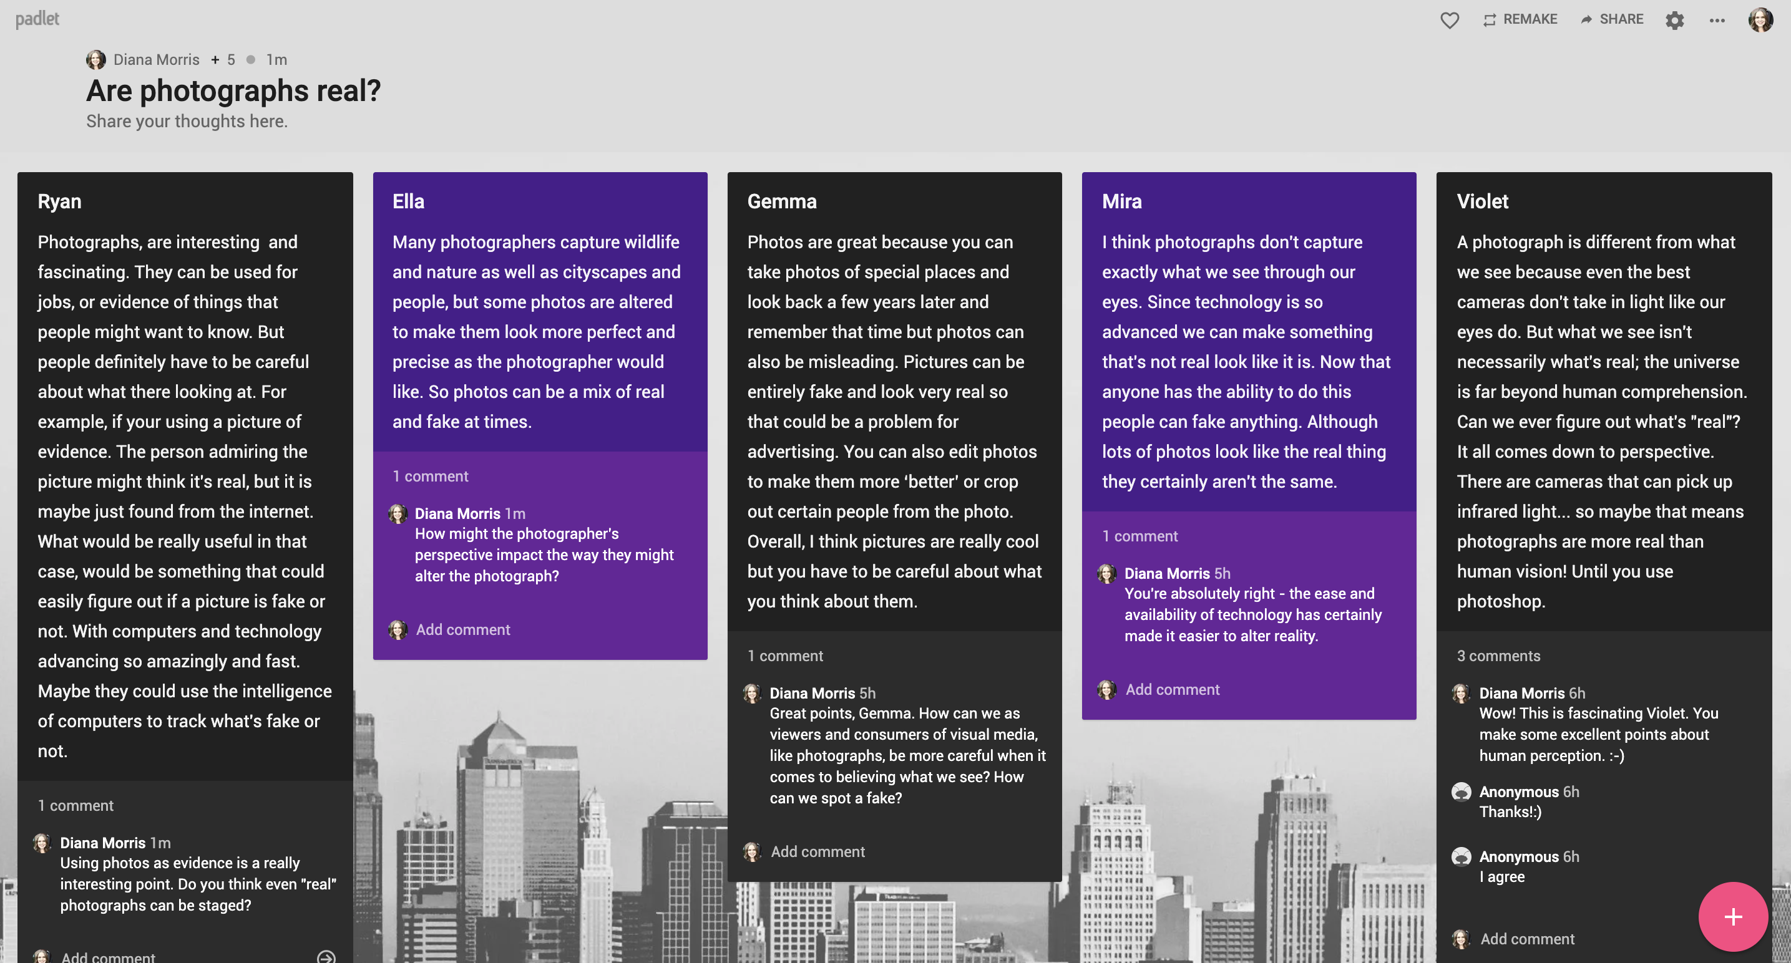
- Gather student questions and wonderings. You can use on online tool, like Padlet or Microsoft Teams.

- Get students to reflect on their thinking using Thinking Routines. “Zoom In” and “I used to think… but now I think…” are two simple, but powerful routines that could be used throughout this unit.
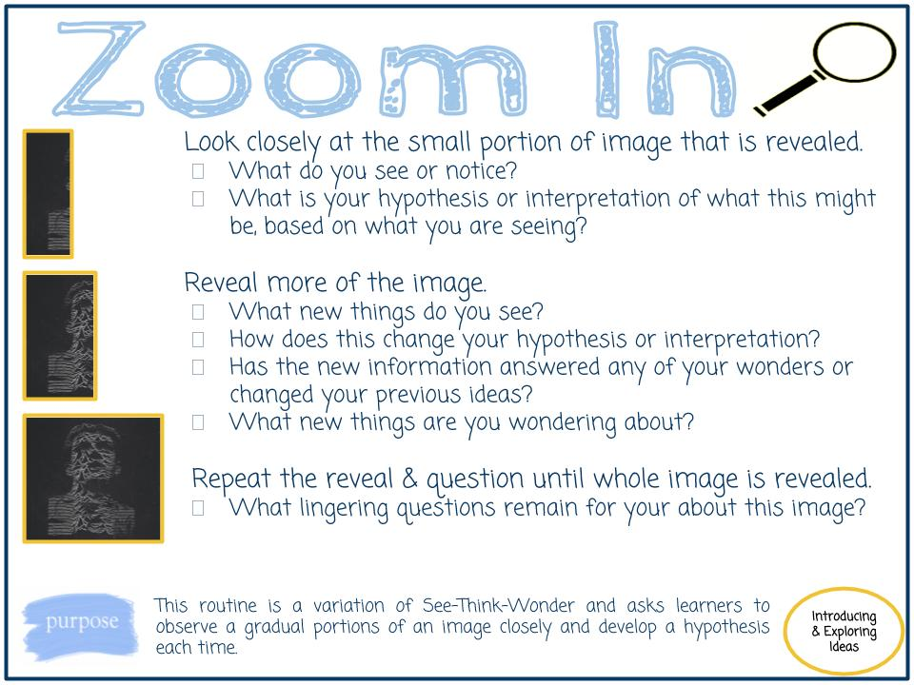
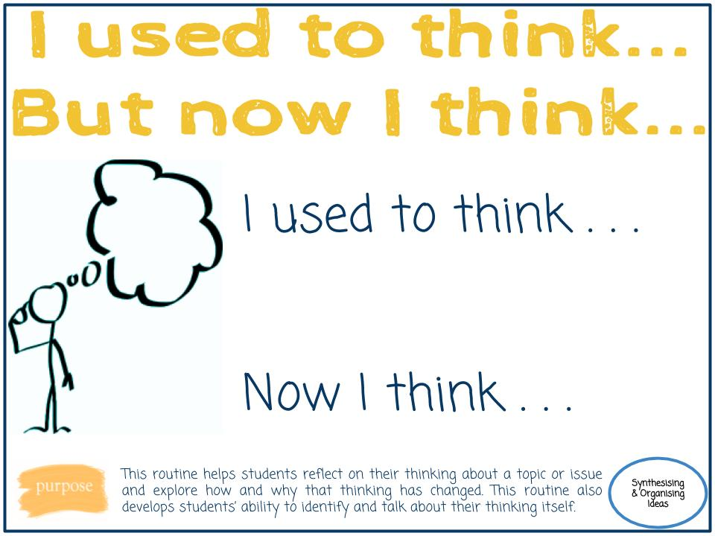

- Challenge your students to create “unreal” photographs using forced perspective photography. Later, have them reflect on their process and how they used perspective to make the viewer see something differently.
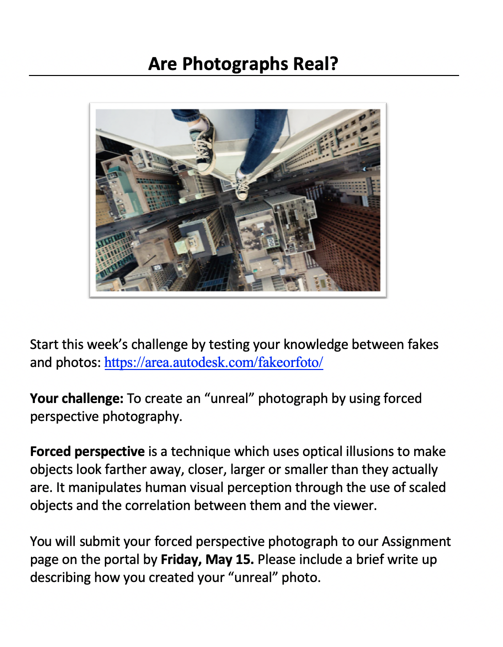
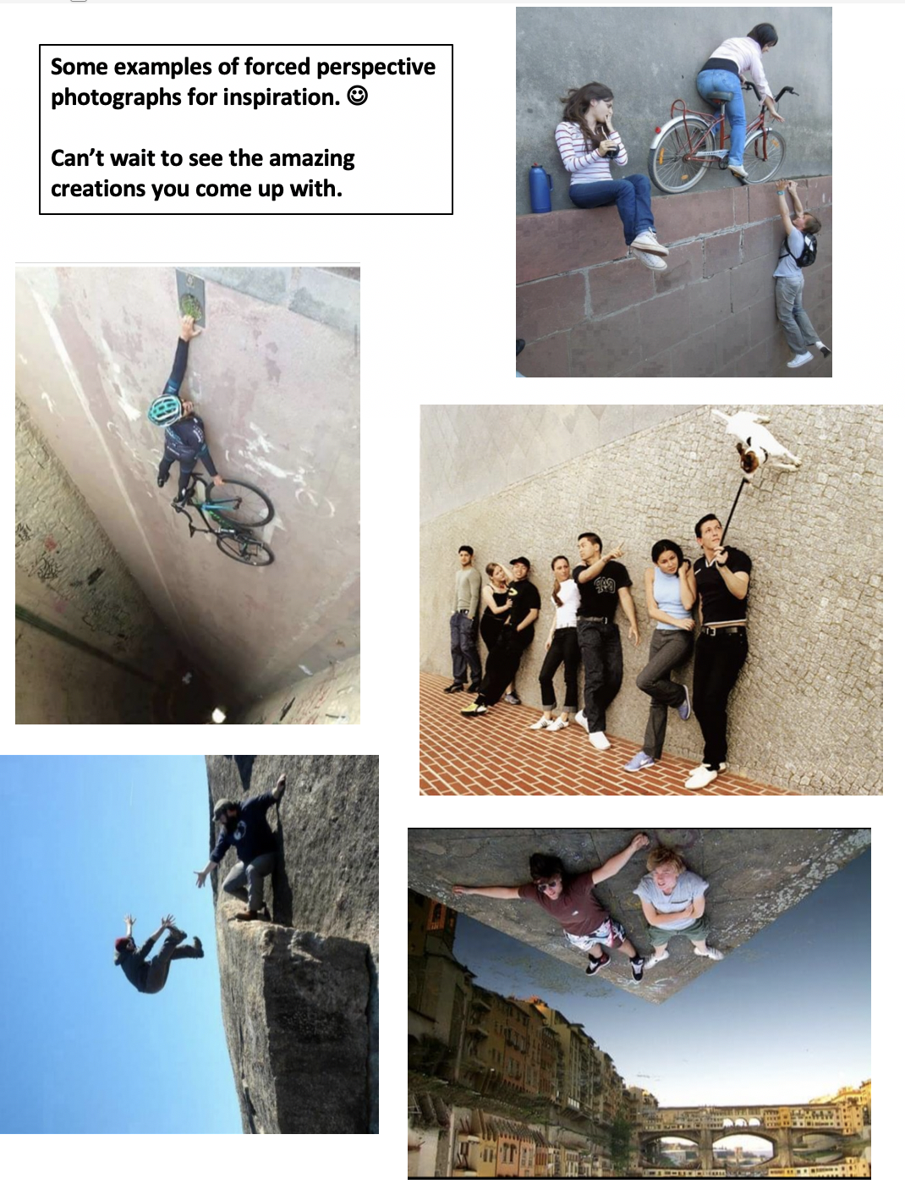

Questions to Consider:
- What are the essential questions students need to answer?
- How are the essential questions connected to the performance/summative task?
- How can the summative task reflect authentic work connected to the areas of study/discipline?
- What problem will the students solve?
- Will the inquiry allow students to self-direct and have agency in their learning?
- How can you augment or redefine the use of technology
to enhance student learning?
- What will the students be able to transfer to their next inquiry?
Online Instructional Model
The TRUDACOT Protocol (4 Shifts Protocol) assists educators with the (re)design of lessons, units, and instructional activities and to think about
      - deeper learning
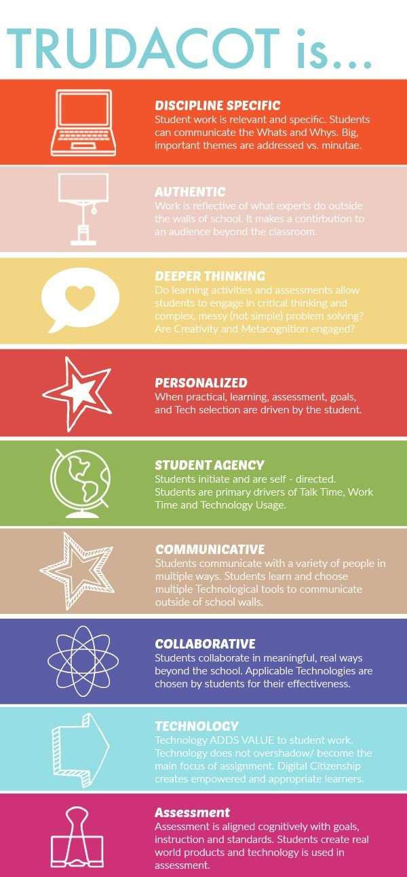
- greater student agency
- more authentic work
- rich technology infusion.

Teaching Online:
BeginningLevel 1: Continue using mail messaging, class blogs, Power Point, e-books, you tube videos, Google images, etc. Begin to explore Microsoft Teams.
DevelopingLevel 2: Explore the functions of the Microsoft Teams platform (video, chat, meeting rooms, file sharing, etc.).
Practicing Level 3: Integrate additional digital technology tools (e.g. Padlet, Animoto, MindMup 2.0, Book Creator, Explain Everything, ShowMe, HaikuDeck, Camtasia, etc.) and explore educational streaming tools (e.g. Curio.ca).

