Pre-Visit Lesson Plan
GRADE(S): 6

DURATION: 45 mins to 1 hour
CONTEXT/RATIONALE:
An introduction to Outdoor School through the lens of systems. Students will know what to expect for their trip to Outdoor School.

Lesson Focus, Big Idea and/or Critical Question(s)
Introduction to Systems and SEL at Outdoor School.
- What is a system? What systems might you encounter at outdoor school?
- How can we prepare ourselves for our visit to Outdoor School?
- What is expected of us when we are there?

Curriculum Connections (Big Ideas, Content, Curricular Competencies)
How can investigation into systems influence the view we hold of ourselves? (e.g. “You are a scientist/detective/outdoor enthusiast”)

Specific Lesson Objectives (SLO’s) – I can …
… I can state what a system is and identify three I might find at Outdoor School.
… I can plan to be successful at Outdoor School.
… I can communicate what is expected of me at Outdoor School.

Materials and Resources – what does the teacher need and what do the learners need?
Slideshow, Access to video potentially (see below for links)
Printed Copy of Compass Activity & Learning Journal
Paper to collect suggestions for cabinmates.
Printed copy of Outdoor Learning Core Competencies Self-Assessment

Note: all supporting documents can be found on the Environmental Learning Resources Tab

INTRODUCTION: How will the lesson begin and engage learners? How will you connect to and activate learners’ prior knowledge?

Hook: Global scale zoom in and can create a Slideshow centered around systems experience.
Note: as you watch this, click on the different living things to learn more info about each and you can zoom in and zoom out to change your scale.
https://scaleofuniverse.com/
Defining Systems
Life is a collection of systems. We encounter and connect with systems every day. Our bodies are interconnected, self-maintaining systems. Every person, every animal, every tree, and every ecosystem is a system.
You can ask students to brainstorm definitions of Systems and what kinds of systems they use every day (digestive system, immune system, etc). Here is a Kids Definition of system: a group of parts combined to form a whole that works or moves as a unit, or a regularly interacting or interdependent group of items forming a unified whole (number systems, solar systems, social systems, river systems, ecosystems, etc..).
Try to consider some of the Systems that you will study at the Outdoor School (hint: a big one will be Ecosystems). You can show this short video clip for a visual of some of the things you will see at Outdoor School (or as a reminder from their last time they were there): Nature is in Session video

DEVELOPMENT: What will you do and what will the learners do? Remember to incorporate key questions throughout the lesson development.
Optional: Here are 2 older videos, that can be played without volume while you explain elements that are being shown like the dining hall, cabins, field studies, etc. for a visual of what to expect at Outdoor School.
- https://www.youtube.com/watch?v=RGMpCQVCWfQ
- https://www.youtube.com/watch?v=PkMzKsrZDH4

Compass Activity:
Introduce to students, use Compass page to gage where the students are at. Go through each of the categories, “Excited”, “Worried”, “Strategies”, “Need to know”.

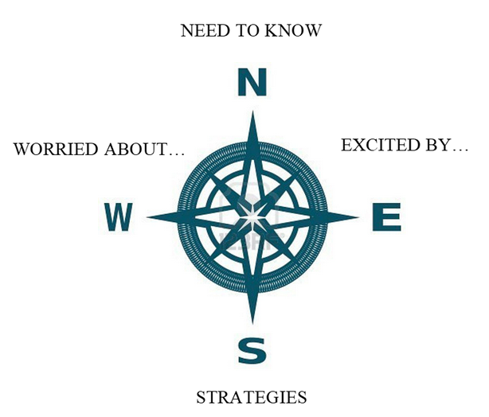

Through debriefing these categories, you should cover these topics:
- What to Pack, Weather expectations
- Counsellor Role & Respect
- Living and working with others (tie in Core Competency assessment to prepare them)
- Cabin requests, taking suggestions so that each student has a support person in cabins and field studies.

CLOSURE: How will the lesson end in a meaningful way?
End with a general Q & A Period, try to avoid “what if” questions. End with Core Competency assessment to help clarify student expectations.
This could be a great time to introduce the Grade 6 Outdoor School Learning Journal: You can assign a page or two to start and students can work on some of it during their time at Outdoor School as well.

ASSESSMENT: How will you know that the learners met/learned/understood the SLO’s?
Refer to the Outdoor Learning Core Competencies Self-Assessment document on the Curriculum Hub

Assessment FOR Learning (What will happen throughout the lesson to check understanding?)

Assessment AS and OF Learning (How will learners show their understanding of concepts/lesson learning?)

Analysis/Reflection of Lesson: What worked well? What didn’t? Did the learners ‘get it’? Why or why not?

