This monthly planning tool has been developed to assist secondary teachers in designing inquiry-based, remote/online learning plans for their students.
Conceptual Planning Framework
Big Idea:

Key Concepts:

Content:

Essential Questions:

Curricular Competencies:

Summative Performance Assessment:

Questions to Consider:
- What are the essential questions students need to answer?
- How are the essential questions connected to the performance/summative task?
- How can the summative task reflect authentic work connected to the areas of study/discipline?
- What problem will the students solve?
- Will the inquiry allow students to self-direct and have agency in their learning?
- How can you augment or redefine the use of technology
to enhance student learning ?
- What will the students be able to transfer to their next inquiry?
Online Instructional Model
The TRUDACOT Protocol (4 Shifts Protocol) assists educators with the (re)design of lessons, units, and instructional activities and to think about
      - deeper learning
- greater student agency
- more authentic work
- rich technology infusion.
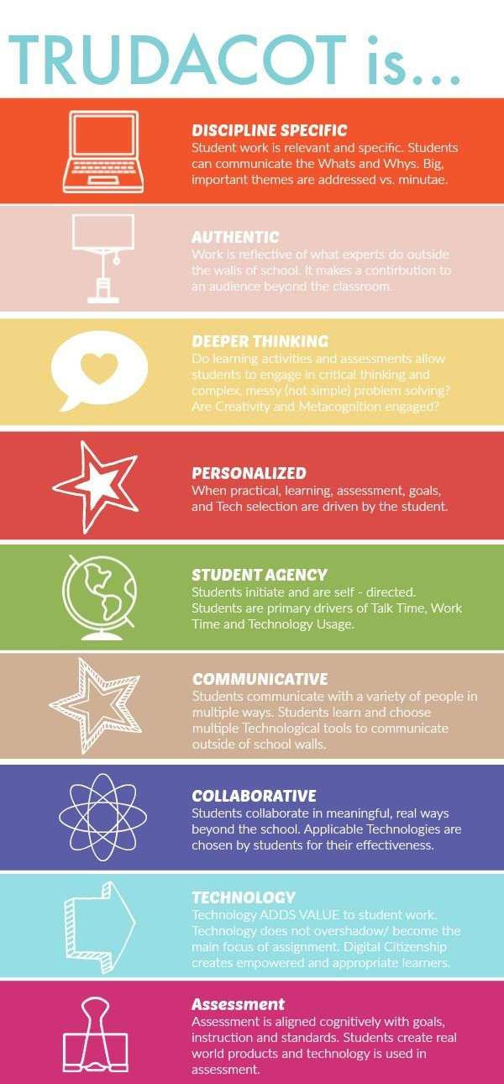

Teaching Online:
BeginningLevel 1: Continue using mail messaging, class blogs, Power Point, e-books, you tube videos, Google images, etc. Begin to explore Microsoft Teams.
DevelopingLevel 2: Explore the functions of the Microsoft Teams platform (video, chat, meeting rooms, file sharing, etc.).
Practicing Level 3: Integrate additional digital technology tools (e.g. Padlet, Animoto, MindMup 2.0, Book Creator, Explain Everything, ShowMe, HaikuDeck, Camtasia, etc.) and explore educational streaming tools (e.g. Curio.ca).

