This document is to be used by students before
STUDENT – TEACHER - PARENT Conferences to assess their competencies in the course so far. This is an indicator of areas of strength, areas they have grown in, and are still working on, as the course progresses.

This would be the document used to guide the conversation at STUDENT – TEACHER - PARENT Conferences.

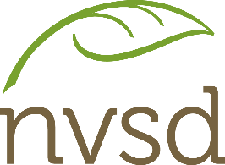
Parent Teacher Interviews: STUDENT-GUIDED DISCUSSION

Highlight the box that you would use to most accurately describe yourself for each competency: (Sometimes / Most of the Time / Always)
OVERALL:

What’s going well?

What’s tricky?

What can I do differently?

SOMETIMES | MOST OF THE TIME | ALWAYS
Communicate ideas,
and solutions to problems,
using content-specific language
 | Identify misconceptions and questions to ask
Use understanding of
course concepts to
identify relationships
and draw conclusions
 | Generate new or refined ideas
 | Transfer and apply learning
 | Reflect on investigation methods, bias and evidence
 | Work co-operatively in groups
Preparation and Participation
 | Arrive to class on time
 | Bring all necessary materials
 | Share information and engage
 | Review content and arrive prepared to discuss concepts
Course work and Productivity
 | Stay on task during class
 | Complete course work in class
 | Hand in assignments on time
Initiative and Success
 | Show interest in learning
 | Always try my best
 | Marks reflect my effort / ability

