Strength

I am good at

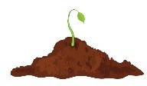
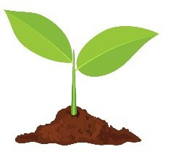
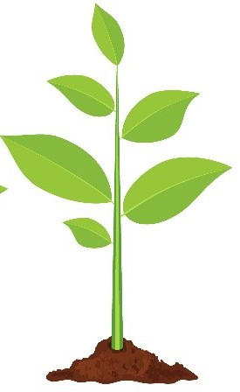
.
Stretch

I am working on

.
Goal
My Learning Plan Goal is to

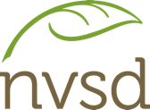
.

Strength – What are you good at?

I am good at

.

Stretch – What are you working towards?

I am working on

.

Goal

My Learning Plan Goal is to

.

Circle One
SMART Goals
Name:

Numeracy Literacy Social/Emotional
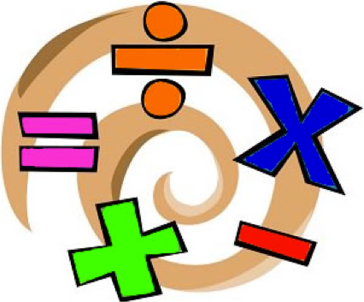
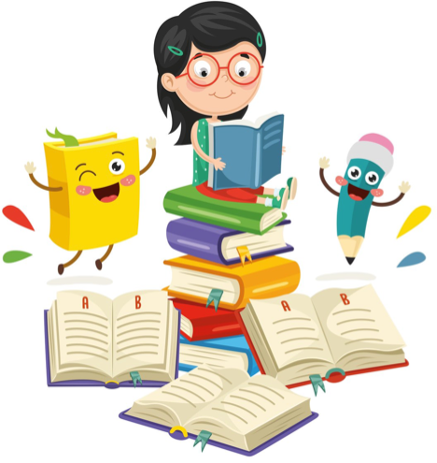
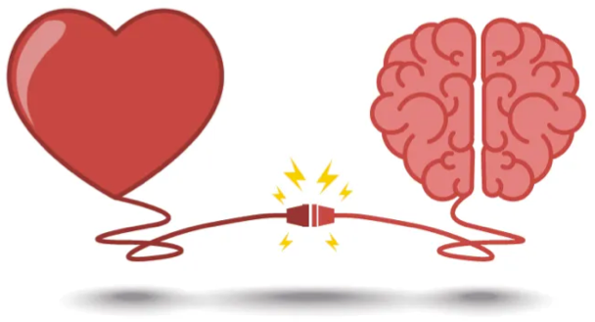
My specific goal is to

.

To achieve this goal, I will

.

I would like to achieve this goal by (time)
.

I know I will have achieved my goal when

.

Goal Progress Tracking
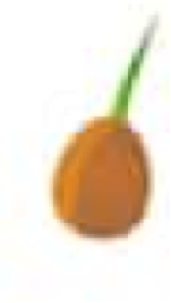
I am beginning to work on my
goal.
I might need some help or
reminders.

I am still working towards my goal.

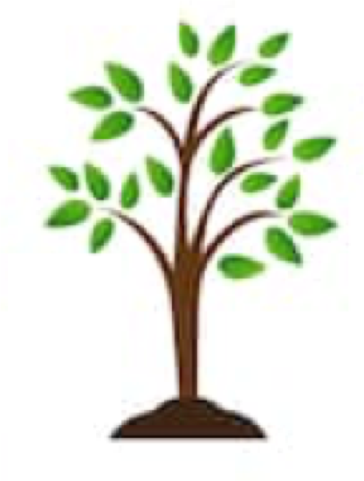
I have achieved my goal!

Hmm... I wonder how I could do more?

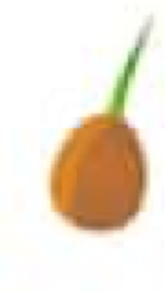
Goal Progress Tracking

I am beginning to work on my goal.
I may have forgotten about my goal.

I am progressing towards my goal, with some help or reminders.

I am still working towards my goal.

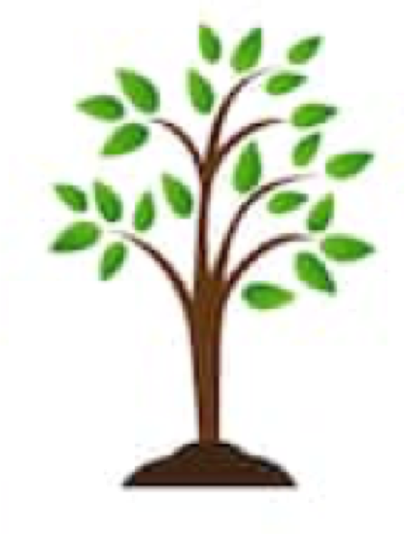
I have achieved my goal!
Hmm... I wonder if I could do more?

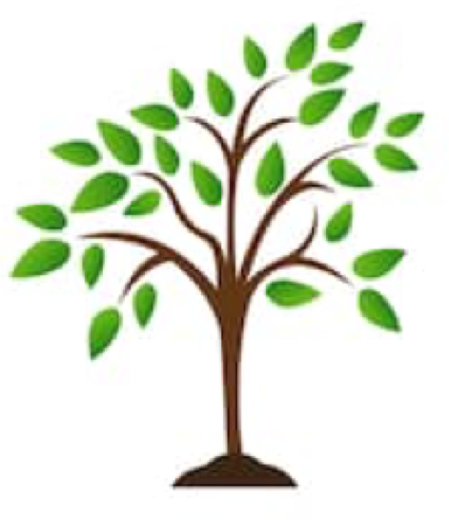
I surpassed my goal!
I went above and beyond.

