Aligning Curricular and
Core Competencies

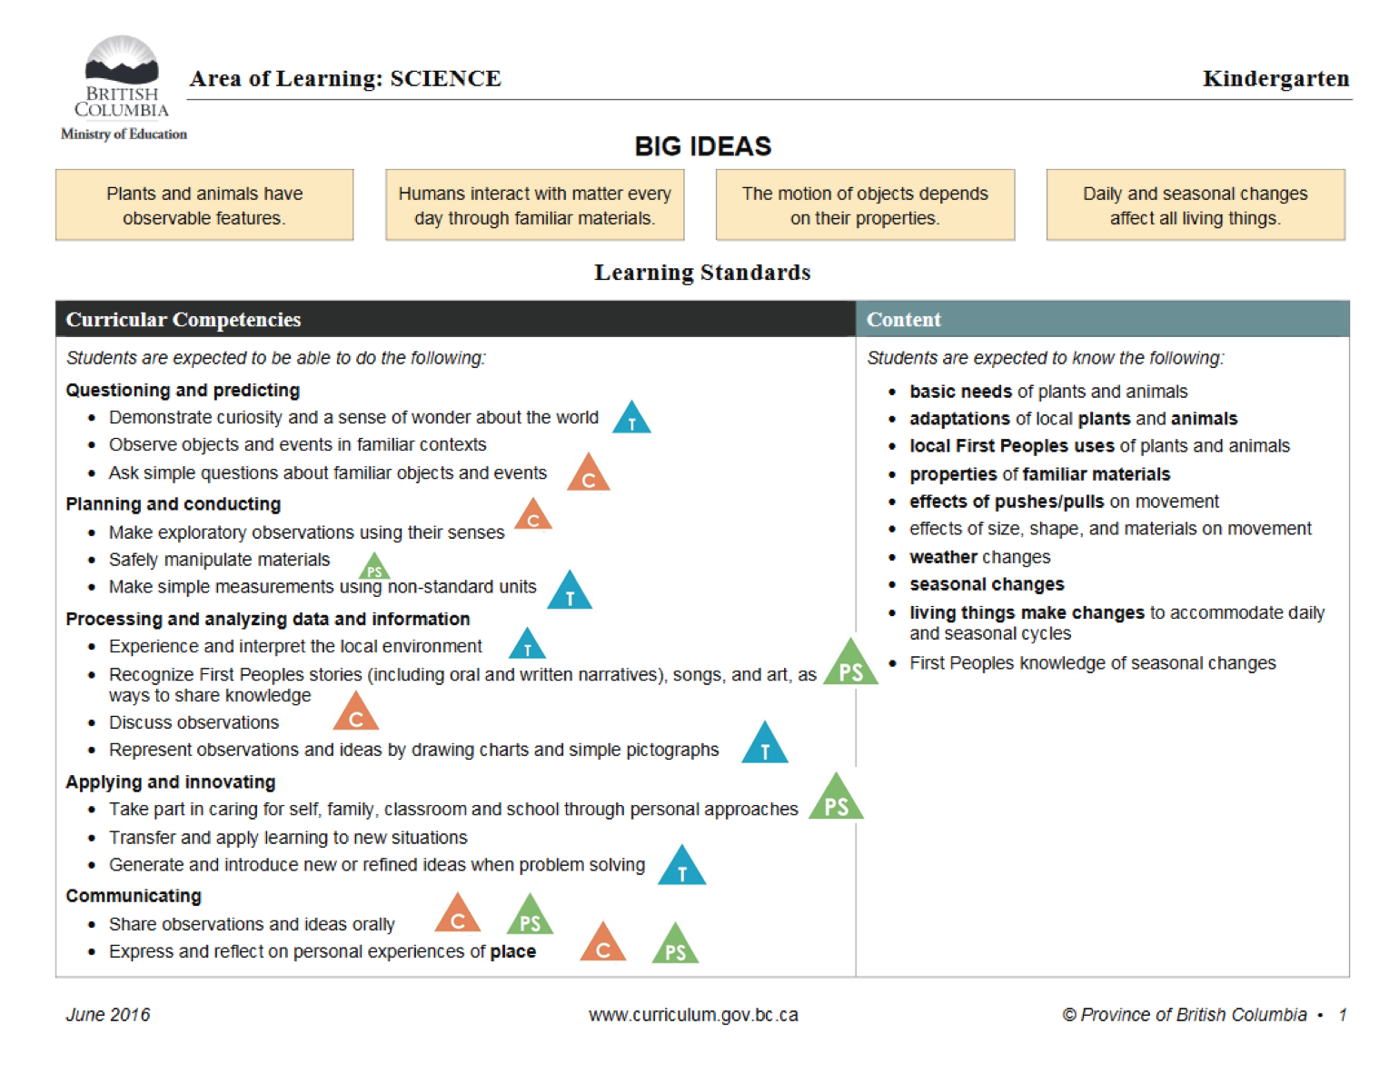

Communication Competency

Communicate Collaborate

COMMUNICATE
Communication Competency Sample K-4 “I Can” Statements
Connect and engage with others (to share and develop ideas):
- I can ask simple questions
- I can listen actively
- I can focus on the speaker

Acquire, interpret, and present information (include inquiries)
- I can understand and share information
- I can present information clearly
- I can present information and ideas to an audience I may not know

COLLABORATE

Collaborate to plan, carry out, and review constructions and activities
- I can work with others toward a goal
- I can take on roles and responsibilities in a group
- I can share important ideas and understand the ways we agree
- I can see different points-of-view and I can disagree respectfully

Recount, reflect and integrate experiences and accomplishments
- I can give, receive, and act on feedback
- I can explain experiences and connect to others’ experiences
- I can connect my learning to my experiences and to others’ experiences

Communication Competency – Communicate

Sample from Kindergarten Science:

I can ask simple questions to get information.

I can talk about what I see, hear, and feel.

I can talk about my ideas.

Communication Competency - Collaborate

Sample from Kindergarten Science:

I can talk about and share what I see, hear, and feel.

I can talk about my ideas with others.

I can work with others towards a goal.

Curricular Competency: Ask simple questions about familiar objects and events

Notice It: Inquiry lessons, wonder wall, centres, field trips
Name It: I can ask simple questions to get information. Nurture It: “Wow! That’s an interesting question about…” “I see that you’re really thinking about…”

Curricular Competencies: Make exploratory observations using their senses. Discuss observations

Notice It: Science labs, community walks, morning meetings, sharing, centres
Name It: I can talk about what I see, hear, and feel. Nurture It: “I love the way you’re looking really closely at…” “I see that you’re using all your senses to explore…”

Curricular Competency: Share observations and ideas orally
Notice It: Sharing circles, partner talks, exit slips

Name It: I can share my observations and ideas
Nurture It: “Thank you for helping us see/understand what

you’re thinking…”

I can ask simple questions to get information.

With support…
I am learning to…

- ask simple questions to get information.
I am beginning to… I can sometimes…

- ask simple questions to get information.
I can…
I am able to…
I can independently…

- ask simple questions to get information.

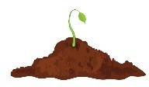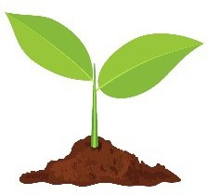

Thinking Competency

Creative Thinking

Critical & Reflective Thinking

CREATIVE

Novelty and Value
- I can get ideas when I play. My ideas are fun for me and make me happy
- I can share ideas that are new to my classmates
- I can show you the things I am interested in by the things I create

Generating Ideas
- I can get ideas when I use my senses to explore
- I can build on others ideas (and sometimes add my own ideas) to solve a problem
- I can thoughtfully learn a lot about something (e.g. by doing research, talking to others or practicing) so that I am able to create new ideas or ideas just pop into my head

Developing Ideas
- I can make my ideas work or change what I am doing
- I can build on the skills I need to make my idea work, and usually succeed, even if it takes a few tries
- I can use the skills I have learned to solve future problems

CRITICAL AND REFLECTIVE

Analyze and Critique
- I can show if I like something or not
- I can explore and appreciate things I learn about other people
- I can show and explain my thinking when I work on different projects

Question and Investigate
- I can ask open-ended questions and collect information
- I can find more than one to way to explore something
- I can tell the difference between what’s real, what is made up, and appreciate when others think different from me

Develop and Design
- I can experiment by doing things differently
- I can reach my goals by trying a variety of ways
- I can engage my audience in different ways

Reflective
- I am able to reflect to on my thinking skills
- I am able to reflect on what I have learned
- I able to to think of things in new ways (Aha moment!)

Thinking Competency - Creative

Sample from Kindergarten Science:

I can use the skills I have learned to solve future problems.

I can change what I’m doing to solve a problem.
I can get new ideas when I play.

Curricular Competency: Demonstrate curiosity and a sense of wonder about the world
Notice It: Inquiry lessons/projects, play, place, field trips
Name It: I can wonder about the world around me. Nurture It: “I love that you are thinking about…” “I wonder what made you think of this…” “What connections can you make…”

Curricular Competency: Experience and interpret the local environment

Notice It: Neighbourhood walks, forest walks, field trips, place, sit spots
Name it: I can recognize, tell you, describe what is in my
local environment
Nurture It: “Wow! Have you seen something like this before…” “Could you build it…” “How do you think it got here”

Curricular Competency: Generate and introduce new or refined ideas when problem solving

Notice It: Science experiments, play, role-modeling, neighbourhood and forest walks
Name It: I can solve problems in many (creative) ways Nurture It: “I wonder if there is a way to solve this…” “I like you used your creative or critical thinking skills to…”

I can wonder about the world around me.

With support…
I am learning to…

- become curious about the world around me.
I am beginning to… I can sometimes…

- be curious about the world around me.
I can…
I am able to…
I can independently…

- show my curiosity about the world around me.

Personal & Social Competency

Personal Awareness & Responsibility Positive Personal & Cultural Identity
Social Responsibility

PERSONAL AWARENESS AND RESPONSIBILITY

Self-Determination:
- I can show a sense of accomplishment and joy
- I can celebrate my efforts and accomplishments
- I can advocate for myself and my ideas

Self-Regulation:
- I can sometimes recognize emotions
- I can use strategies that help me manage my feelings and emotions
- I can persevere with challenging tasks

Well-Being:
- I can participate in activities that support my well-being
- I can participate in activities that support my well-being and tell/show how they help me
- I can take some responsibility for my physical and emotional well-being
- I can make choices that benefit my well-being and keep me safe in my community, including my online interactions

POSITIVE PERSONAL & CULTURAL IDENTITY

Relationships and cultural contexts:
- I can describe my family and community
- I am able to identify the different groups that I belong to
- I understand that my identity is made up of many interconnected aspects (such as life experiences, family history, heritage, peer group)

Personal values and choices:
- I can tell what is important to me
- I can explain what my values are and how they affect choices I make

Personal strengths and abilities:
- I can identify my individual characteristics
- I can describe/express my attributes, characteristics, and skills

Contributing to community and caring for the environment:
- With some support, I can be part of a group
- I can participate in classroom and group activities
- I can participate in classroom and group activities to improve the classroom school, community, or natural world
- I contribute to group activities that make my classroom, school, community, or natural world a better place
- I can identify how my actions and the actions of others affect my community

Solving problems in peaceful ways:
- I can solve some problems myself and can identify when to ask for help
- I can identify problems and compare potential problem-solving strategies
- I can clarify problems, consider alternatives, and evaluate strategies
- I can clarify problems or issues, generate multiple strategies, and consider consequences

Valuing diversity:
- With some direction, I can demonstrate respectful and inclusive behavior
- I can explain when something is unfair
- I can advocate for others

Building relationships:
  - With some support, I can be part of a group
  - I am kind to others, can work or play co-operatively, and can build relationships with people of my choosing
  - I can identify when others need support and provide it
  - I am aware of how others may feel and take steps to help them feel included
  - I build and sustain positive relationships with diverse people, including people from different generations

Personal Awareness and Responsibility

Sample from Kindergarten Science

I can celebrate my efforts and accomplishments. I can persevere with challenging tasks.

Positive Personal and Cultural Identity
Sample from Kindergarten Science

I can describe my family and community. I can tell what is important to me.

Social Responsibility
Sample from Kindergarten Science

I can solve some problems myself and can identify when to ask for help.

I can participate in classroom and group activities.

Curricular Competency: Share observations and ideas orally
Name It: I can share what is important to me

Notice It: During observation walks, science experiments, class discussions, reflections, observational drawings Nurture It: “ I like how you told us about…” “You clearly showed your thinking and explained why…”

Curricular Competency: Express and reflect on personal experiences of place

Name It: I can describe my family and community Notice It: Neighbourhood walks, brainstorming, sharing/ show and tell, circle, observations of seasonal changes Nurture It: “I like how you connected it to…” “Does that remind you of a time…”

Curricular Competency: Take part in caring for self, family, classroom and school through personal approaches
Name It: I can participate in classroom and group activities to improve
the classroom school, community, or natural world
Notice It: Being prepared, helping cleanup, identifying how students do things
Nurture It: “Thank you for helping tidy up…” “I saw that you
helped your classmate…”

I can share what is important to me.

With support…
I am learning to…

- share my ideas.
I am beginning to… I can sometimes…

- share my ideas.
I can…
I am able to…
I can independently…

- share my ideas.

Cheat Sheet Prompts to Help “Nurture” Core Competencies

- Wow! That’s an interesting question about…
- I see that you are really thinking about…
- I like the way you are really looking closely at…
- I see that you are using your senses to
explore…
- I wonder what made you think of this...?
- I love that you are thinking about…
- I wonder if there is a way to solve this…?
- Wow! Have you seen something like this before…?
- I like that you used your creative/critical thinking skills to…
- I like how you told us about…
- You clearly showed your thinking and explained why…
- I like how you connected to…
- Does that remind you of a time…?
- I noticed that your helped your classmate…
- Thank you for helping
- What makes you say that…?
- What could you have done differently…?
- How did you work with your group to develop your ideas…?
- How did you come up with your ideas…?
- Did you share your ideas with someone else…?
- What does this make you think of…?
- Did everyone in your group have the same/different ides…?
- What helped your learning…?
- What got in the way of your learning…?
- How did you feel when you were doing…?
- I noticed that you…

Probing Questions to Support Deeper Self-Reflection

  - Wow! How did you get to be so good at ?

  - What did you need to do to achieve ?

  - What do you need to do to improve ?

  - What do you plan to do to achieve ?

  - What strategies will help you ?

  - How will you feel when you achieve ?

I can ask simple questions to get information.

With support… I am learning to…

- ask simple questions to get information
I am starting to…

- ask simple questions to get information
I can sometimes…

- ask simple questions to get information.
I am able to…

- ask simple questions to get information.
I am consistently able to…

- ask simple questions to get information.

