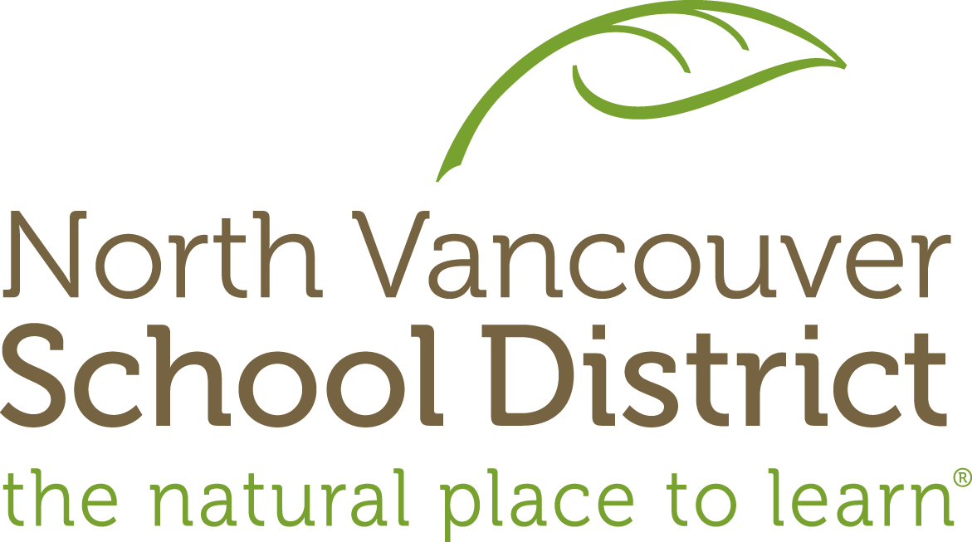

Field Study Planner

Overview
Field Study: | Forest | Conceptual Lens: |  | Senses
Overview: | Students venture through the Cheakamus Centre’s extensive trail networks to experience the biodiversity of the coastal temperate rainforest through hands-on sensory awareness activities. These activities increase the ability to observe and be present in nature, emphasize getting to know local species and their habitats, and inspire local action and stewardship. In addition to learning about the interconnectedness of the plant and animal species, students will also explore human interactions with the forest environment, and the important role they play in our lives.
Grade: | 4
Duration: | 2 hours | Season: | Spring

Stage 1 – Desired Results
Big Ideas
What will students understand? Copy from ODS Curriculum Map.
Living things sense and respond to their environment (Science 4).

Core Competencies
What specific Core Competencies will be developed in the field study?
Communication: Students will reflect on place-based experiences in a coastal temperate rainforest.
Critical Thinking: Students will ask & answer question through direct observation.
Personal & Social: Students will explore human impacts, and how they can contribute to caring for the natural world.
Concepts | Field Study Understandings |  | Transfer Goals | Essential Questions
Unpack the Big Idea  Senses  Interactions  Environment  Survival  Stewardship  Interdependence  Ecosystems  Adaptation | What will students understand at the end of the field study?  Students will understand that…  Living things have senses that detect changes in their environment.  Living things respond to changes in their environment.  Anything that causes a living thing to react is called a stimulus.  Response to a stimulus is important for its survival. |  | What will students be able to apply from the field study in the future?  By the end of the field study, students will be able to independently use their learning to…  Use their sense to make observations in the environment  Connect to place and understand their role and responsibility as stewards of the environment  Discover and compare their senses to a variety of organisms, both aquatic and terrestrial.  Develop a plan of action to address a selected problem or issue | Questions are open-ended, debatable, foster inquiry, and are revisited across field studies.  Students will keep considering…  How do living things sense, respond, and adapt to stimuli in their environment?  How do I observe nature? What does using my senses in nature look, sound, feel, taste and smell like?  How do my senses compare to the senses of other plants & animals?  How is sensing and responding related to interdependence within ecosystems?
Cheakamus Centre Principles
Describe how specific CCPs will be integrated into the field study.
How does the field study reflect Cheakamus Centre Principles (Place, Community, Inquiry, Personal Connections, and First Peoples’ Perspectives)?
Place: Student will explore and make observations in a coastal temperate rainforest
FPP: Students will develop place-based knowledge about the coastal temperate rainforest, learning and building upon aboriginal knowledge and other traditional knowledge of the Coast Salish People.
Personal Connections: Place-based learning provides the basis for an intuitive relationship with the natural world, connections to the rainforest ecosystem and sense of relatedness that encourages life-long harmony with nature.

Alignment Check:
Are your concepts, unit understandings, transfer goals, and essential questions connected and supportive of your Big Idea?
Curricular Competencies |  | Content
What students will be able to do. Choose from ODS Curriculum Map.  Demonstrate curiosity about the natural world  Explore and pose questions that lead to investigations  Safely use appropriate tools to make observations and measurements  Make observations about living & non-living things in the local environment  Collect simple data  Experience & interpret the local environment  Identify First Peoples perspectives & knowledge as sources of information  Identify some simple environmental implications of their & others’ actions  Contribute to care for self, others, & community through personal or collaborative approaches  Express & reflect on personal, shared, others' experience of place |  | Specify statements from Field Study Understandings  Students will know that…  Sensing & responding: humans (5 senses), animals, plants (response to light, touch, water, gravity etc.)  Direct experience of coastal temperate rainforest through the senses.  Biodiversity in the rainforest  Aboriginal knowledge of the rainforest  Relationship between self and environment  Traditional stories as evidence about Coast Salish culture  Vocabulary: ecosystem, biodiversity, temperate rainforest, habitat, coniferous , deciduous

Stage 2 – Evidence: Assessing for Understanding
Assess: Field Study
Formative:  Checkpoints for students to show their knowledge and skills during the field study | Summative:  Final assessments of knowledge and skills at the end of the Field Study
Teachers should consider how formative assessment in outdoor learning is informal, varied, and ongoing throughout the field study. | Teachers should consider how summative assessments revisit essential questions, involve self-reflection, and builds towards Final Task.
Assessing prior knowledge:  -Share “What is a rainforest?”  Students will demonstrate their knowledge, skills & understanding by:  -describing the temperate rainforest ecosystem using sensory details  -pair-sharing observations & questions  -sharing in small groups or large group examples of how they can be stewards of the forest and nearby nature  -personal reflection on the importance of forests  -making a personal connection to nature (solo sit, mindfulness walk) | Reflection, Walk & Talk or group circle:  - Think quietly to yourself about/ describe some things you learned today.  - Think quietly to yourself about/describe some things you learned today that are not facts (e.g. different ways to look at or think about things).  - Think quietly to yourself/describe some things you enjoyed today.  - What are some questions you still have about organisms or anything else we saw today?  - Pretend you are talking to a friend or family member. Describe to them how to make observations in nature. How might you describe what you did on this hike with someone else?  - Think of some places near your home where you could do these sorts of explorations.  Learning Journal: Describe a special place in nature, a memory of being in nature, a special experience in nature.

Stage 3 – Executing the Learning Plan
These learning events/activities are suggested activities. Teachers should add, revise, and adapt based on the needs of their students, their own personal preferences for resources, and a variety of instructional techniques.
Facilitation Tips
Safety for students: stay with group. Have a counsellor or responsible student pair remain at the back of the group while hiking.
Safety for organisms: remain on trail. Do not pick or remove live organisms. Model leave no trace ethic.
Exploration techniques: Slow down, get down & look around. Use Hand lenses: The best and simplest tool to engage students directly with nature. It inspires students to look closely, provides an immediate different perspective, and lets students see things they can’t see otherwise.
Use Walk & Talk as a transition between activities.

Warm-up
Sensory Wake-up Circle (Get Outdoors!) Walk and Talk Question: Which sense could you give up? Which sense could you not live without?
Solo Sensory hike: Space the students out 10-20 seconds apart on the Moss Trail. Walk for 2-3 minutes. Circle up at the end of trail in a clearing. Ask students to share an ‘I notice’.

Main Activity (Example)
Tiny Treasures
Opportunity: Collect & Share some of the tiny treasures that inhabit this place…in a very sensory way!
Gear up! Hand lens, clipboard, pencils, egg carton (1 per pair), camera (optional)
Explore & Discover: What tiny objects can you discover if you look very closely in every nook and cranny of this place?
Make it happen: Collect 12 little objects to fill each hole in your egg carton. Try to find a diverse and varied sampling of many tiny treasures that people seldom notice unless they look very carefully.
For the record: Photograph or draw, (optional: colour), & label your Tiny Treasures on the record sheet
Share your work: Invite others to experience your Tiny Treasures by asking them to close their eyes and use their other senses to guess each item you put in the palm of their hand.

Reflection
- How successful were you as a Tiny Treasure Collector? Why?
- What were the three best things about this experience? Why?
- What can you say you learned during this activity? Explain.
- What were your favourite three treasures? Why?

Closing
Storytelling Circle

Other sensory activities
Sight
Rainbow Chips (Get Outdoors!) – Hand each participant a rainbow chip, telling them that every colour of the rainbow exists in nature all around us, and send them off to match their colour chip as closely as possible with something natural. Ask them not to pick their matched items if it is alive, but to show it to someone close by. Once they have found a match, give them another chip to match. Q: What surprised you the most about this activity? What colours were hardest to find?

Instant Cameras (Get Outdoors!)

ABCs We See: Pair students up and send them outside with an alphabet checklist. Their challenge is to find and list (or draw) something in nature for each letter on the list. Could use digital cameras, and create a digital slideshow.

Digital Photo Sensory Shoots – students work in 2-3s. Ensure each group has a camera. Give each group a sensory theme (colour, texture, smells, sounds, etc.) and have them take photos to put together a slideshow.

Back and Belly Observations: I notice, I wonder, It reminds me.

Hearing
Sound Mapping (Get Outdoors!)
Mindfulness Walk
Solo sit

Touch
Blind walk (Hug a Tree)

Smell
Forest Cologne (Get Outdoors!)

Resources:
Grade 4 Backpack (Get Outdoors!): Sensory Warm-up, Rainbow chips, Sound Mapping, Instant Cameras, Forest Cologne)
ABC’s we see
I notice, I wonder, It Reminds me
Walk and Talk
Tiny Treasures
Storytelling: The Great Blanket of Moss, Legend of the Cedar Tree
Ethnic Plant Guide
Walk of Wonder

Teacher: Field Study Reflection
What aspects of the field study went well?

What did students struggle with?

What did you struggle with?

What would you add/revise the next time you taught this field study?

What connections can I make back to my school learning community?
Challenge your class or school to get involved in a meaningful action project that encourages forest stewardship.
My Special Place (Get Outdoors p. 59) Students choose and explore a special natural place in their schoolyard, park or other area. They describe the local environment using sensory details; they reflect on its importance, and they discover their own connections to it. Suggested Reading List about Special Places and Connections (p. 63).

