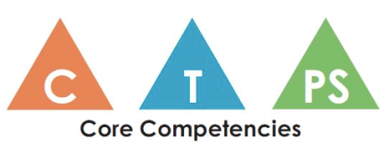
Subject Area:

Core Competency | (Facet + Learning Activity)
COMMUNICATION

Subject Area:

Core Competency | (Facet + Learning Activity)
THINKING

Subject Area:

Core Competency | (Facet + Learning Activity)
PERSONAL and SOCIAL

